Module 12:

Managing Multiple Projects and Resource Pools

Contents

Module Overview 1

Lesson 1: Linking Multiple Projects 2

Overview of Multiple Projects 3

Using New Window Feature 5

Linking Across Projects 8

Analyzing the Effects of Changing Values 10

Practice: Linking Multiple Projects 12

Lesson 2: Working with Resource Pools 13

What is a Resource Pool 14

Creating a Resource Pool 16

How to Share Resources across Multiple Projects 17

Viewing Resource Usage in the Resource Pool 20

Practice: Working with Resource Pools 22

Lesson 3: Working with Master and Sub-Projects 23

Overview of Master Projects 24

Creating a Master Project and Inserting Sub-projects 25

Leveling Resources across Projects 27

Practice: Working with Master and Sub-Projects 30

Summary 31

12

.

# Module Overview



Most project managers are managing more than one project at a time. Some are smaller projects which are part of a larger program of projects. Managing resources across the projects and the various project scheduling details can be complicated. Project 2010 provides the ability to share resources across projects on a small scale. It also provides functions for combining individual projects into larger programs for reporting purpose.

In this module we will discuss:

1. Linking Multiple Projects
2. Master Projects
3. Working with Resource Pools

# Lesson 1: Linking Multiple Projects



When managing more than one project, combining information from multiple project schedules can be helpful. The completion date of a task in one project could influence the start date of a task in another project and what would be the impact if a change was made.

In this lesson we will discuss:

1. Overview of Multiple projects
2. New window
3. Linking tasks across projects
4. Analyzing the effects of changing values

## Overview of Multiple Projects



Managing more than one project at a time can be challenging. Whether the projects are part of a larger program or separate ventures, combining the information to see a big picture can be valuable. Knowing how the resources are distributed across the projects and the impacts of resource availability on project schedules will give you more information to make better project management decisions.

Project 2010 has various capabilities for handling information concerning multiple projects:

**Master Project:**  This is the easiest method of handling multiple projects. A project file is created and saved usually with a name inferring that the file will be a Master Project. Other existing projects are inserted into the Master Project file. The inserted projects are called member projects. When the Master Project is opened, the member projects can optionally be opened inside the Master Project. Reporting across the projects is easy with the aid of groups, custom values and filters. Master Projects are very helpful when managing large projects or managing unrelated projects. Inserted projects may be managed by multiple project managers and all information combined when necessary.

**External links between projects:** A task in one project can be the predecessor of a task in another project. Relationship links can be created across projects using a temporary file created by the New Window function. Links may also be created when project files are opened in a Master Project.

**New Window:**  This function is used to combine projects on a temporary basis for reporting across projects or for resource leveling across projects.

**Resource Pools:** Typically resources are not dedicated to one project but are shared over many projects. Using an external resource pool can allow for resource sharing across multiple projects. The ability to see all resource assignments in one place could then be viewed through any of the sharer projects or through the resource pool. Another advantage of using a shared resource pool is that resource availability could be updated in the resource pool and the impact will be seen through the sharer projects. Resource leveling can then be performed across the sharer projects using project priorities.

Shared resource pools are constructed using links. Best use for shared resource pools is a limited number of projects and project managers accessing the same resource pool file. Shared resource pools use exact disk path locations. Once the links are created the file locations cannot be moved without breaking the links.

**NOTE:** *This structure is not meant for large resource pools with multiple project managers. Project Server was designed to handle the need for increased functionality.*

## Using New Window Feature



Use the New Window feature to combine projects into one window for reporting purposes. The New Window feature will create a temporary window where information from the selected projects may be updated. This view is considered temporary and is not usually saved.

**To create a temporary New Window view:**

* Open all projects to be combined.
* **View** 🡪 **New Window.**
* Select specific projects you wish to combine into a new project.
* Select the View format.
* Click **OK**.

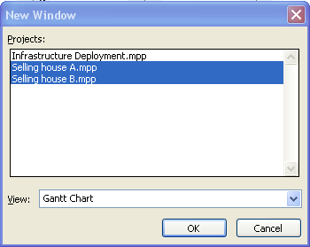

Below is an example of projects combined in a new window. The outline level has been rolled up to see a high level picture of when the projects are scheduled:

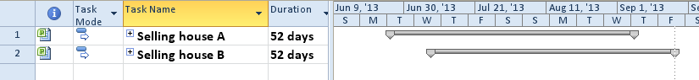

Expanding the WBS outline level to the next level will enhance the view. When similar task names are used, inserting the Project column will give more information regarding the origin of the task. See the example below:

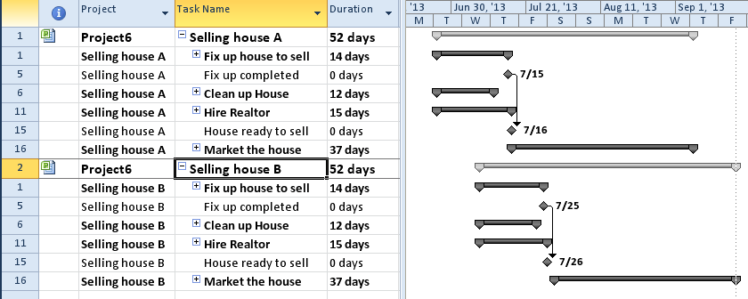

When projects are combined, groups and filters may be used to help refine information. In Module 8 we discussed creating a custom group that would show start dates of tasks grouped by week. With the outline levels fully opened, this group is applied to the new window view below. Notice the different project names in the project column:

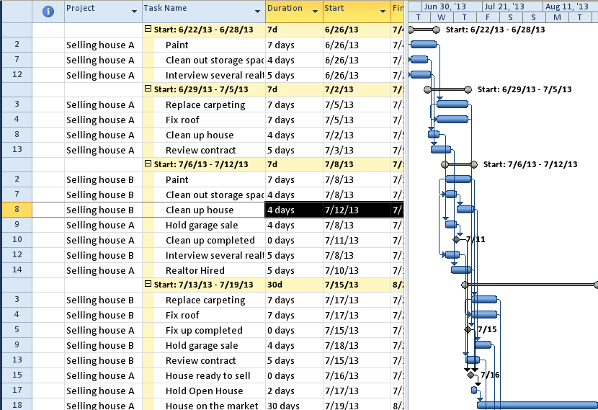

**Best Practice:** *It is advantageous to use short project names. At times the entire project location path will be shown in the Project column. If this occurs, consider creating a custom task field called “Project Name” and create a short project name to be used for reports.*

## Linking Across Projects



Tasks in one project might influence when a task in another project may start. Linking tasks from one project to another is a helpful tool to assist with this scheduling challenge. The links between projects are called external dependencies. These dependencies are easily created by opening the projects that contain the tasks to be linked in a temporary window.

**NOTE:**  *The links that are between projects carry direct path file locations. After a link has been created, do not move the files.*

To create an external dependency between projects, the projects that contain the tasks must be open in read-write mode. In the previous lesson we discussed combining projects into a temporary new window. Once the projects are combined, open the outline level in the projects to view the tasks to be linked.

**To create external dependencies:**

* Open all projects to be combined.
* **View** 🡪 **New Window.**
* Select specific projects you wish to combine into a new project.
* Select the View format.
* Click **OK**.
* Click the predecessor task.
* Press and hold CTRL and click the successor task.
* Click the link button  on the Task bar.

The result is shown below. When the painting for House A has been completed, painting for House B can start. The tasks and link is outlined below:

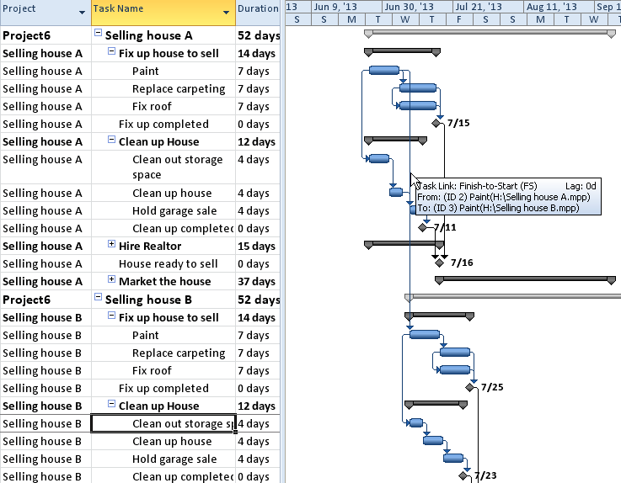

Once a link is created, close and do not save the temporary file. The relationship has been updated to the member files. Below is the view of the external link in a member file. The link appears as a task but is grayed out. The project name column has been added to the view.

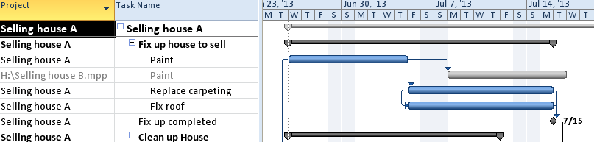

## Analyzing the Effects of Changing Values



If a change is made in the project which contains the predecessor task, the impact will be seen in the project with the successor task. The project containing the successor task does not have to be open at the time of the change.

In the example below, painting of House A is scheduled to conclude on July 16. Painting House B is schedule to start on July 17.

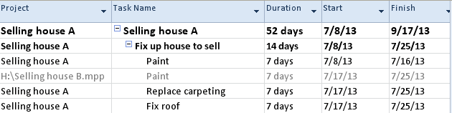

A change is made in the duration for painting House A from 7 to 10 days. The Selling House B project is not open at the time the change was made. Note the changes in the dates for the task to paint House B.

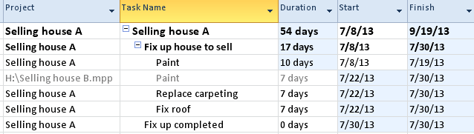

When the Selling House B project is opened, the Links between Projects box will appear. This is an alert to let you know there has been a change to your project flowing from an external link.

* To accept the changes, click **All** to accept all**.**
* To reject the changes, click **Close**.

The **Links Between Projects In** dialog box is shown below:

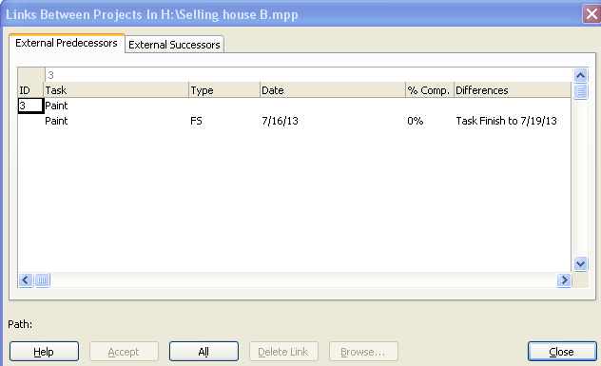

To view the Links Between Projects In dialog box below:

* **Project** 🡪 **Links Between Projects**

You can also choose to accept or delete links individually.

## Practice: Linking Multiple Projects



*The Practice page is where you write detailed instructions for completing work listed as Exercises.*

*Type the Exercise Title and write a brief summary what the student will be doing in the exercise. Then list your ideas what they will be doing.*

*SAMPLE*

*In this practice you will create a Project Server Authentication profile and then configure the local cache settings in Project Professional 2007.*

*Exercise 1: Create Project Server Authentication Profile*

*In this exercise you will create Project Server authentication profile to connect to the Project Web Access site.*

Perform the following exercise on the PS07 virtual machine.

1. *From the* ***Start*** *menu, click* ***All Programs*** *🡪* ***Microsoft Office*** *🡪* ***Microsoft Office Tools*** *and click* ***Microsoft Office Project Server 2007 Accounts****.*
2. *In the* ***Project Server Accounts*** *dialog box, click* ***Add****.*
3. *In the* ***Account Properties*** *dialog box, and complete the following settings and click* ***OK****.*

|  |  |
| --- | --- |
| *Setting* | *Perform the following:* |
|  | |
| *Account Name* | *Type* ***Project Server*** |
| *Project Server URL* | *Type* ***http://epm/pwa*** |
| *When connecting* | *Select* ***Use Windows user account*** |
| *Set as default account* | *Select check box* |

# Lesson 2: Working with Resource Pools



External resource pools are an effective means of tracking resource allocations. Most resources will have work assignments that span multiple projects. Sharing resources using an external resource pool will allow for resource availability to be controlled and assignments seen in a single location.

In this lesson we will discuss:

1. What is a resource pool.
2. Creating a resource pool.
3. Sharing resources across multiple projects.

## What is a Resource Pool



A resource pool is an .mpp file which contains resource information but does not contain tasks. Project 2010 is written to acknowledge this format and will treat the file differently than project file which contains tasks.

Once a resource pool is created, mutiple project schedules may share the resources of the external pool. Some of the benefits of sharing resources in this manner are:

* All assignments for projects sharing the resources may be viewed using the Resource Usage view in any member project file.
* Resource assignments may be leveled across multiple projects.
* Project and task priorities may be used during resource leveling.
* The Team Planner View will show assignments across projects (MSP Pro only).
* Updating resource calendar availability will affect all assignments from projects sharing the resource pool.

**Some restrictions are:**

* Resource pools are normal read-write files. If multiple project managers try to access the file at the same time the first user will open the resource pool in read-write access and subsequent users will have read-only access. If a project manager who has opened the resource pool read-only makes changes to an assignment in a project schedule, updates to the resource pool will be made at a later point in time.
* Maintaining the resource pool must occur when the resource pool is open in read-write mode. Other users may not have the resource pool open when maintanence occurs. For convenience. it is best to add new resources and maintain resource calendars at the beginning or the end of the work day.
* External resource pools sharing and resource assignments are built using a network of links. Once a link is established, the files may not be moved or the links will be broken. Links will contain disk locations.
* Due to the above limitations, the fewer users accessing the resource pools the better. Project Server 2010 is better suited for large scale projects with multiple project managers accessing shared resource data.

## Creating a Resource Pool



The easiest method to create a resource pool is to create a blank project file. The contents of the file will indicate that is a resource pool. Once a blank file has been created, add the resources which will be shared across projects.

**To create a resource pool:**

* Open a new project file – **File** 🡪 **New** 🡪 **Blank Project** (double click).
* **Task** 🡪 **Gantt Chart** 🡪 **Resource Sheet**.
* Enter information for each resource.
* **File** 🡪 **Save as**.
* **File** 🡪 **Close**

**Best Practice:**

* *Name the resource pool with name that will identify the file as a resource pool.*
* *Using last name first name for resource names will make finding of resources easier.*

## How to Share Resources across Multiple Projects



Projects that will be sharing the resources of the resource pool may contain some resources or no resources. If the same resource name is contained in the project schedule and the resource pool, Project 2010 will not combine the 2 resources and will treat them as separate resources.

Looking at the resource sheet of the Selling House A project we can see that the file does not resources.

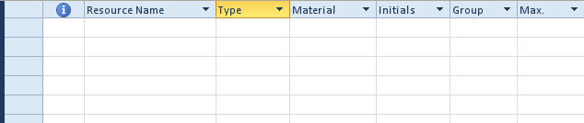

**To share resources using a resource pool:**

* Open the resource pool file
* Open the file that will be sharing the resources
* **Resource** 🡪 **Resource Pool** 🡪 **Share Resources**

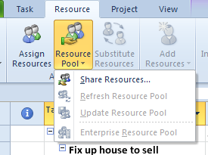

The Share Resources dialog box will open:

* Click **Use Resources**
* From the **From** drop down list, select an open resource pool  
  **NOTE:**  Resource sharing may occur from other open project schedules as well as a resource pool but sharing may only be from one project file.
* Click **Pool takes precedence**
* Click **OK**

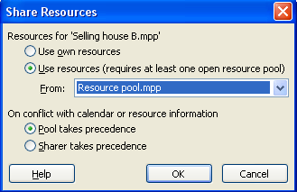

The resource sheet now contains resources from the pool that was chosen in the above step.

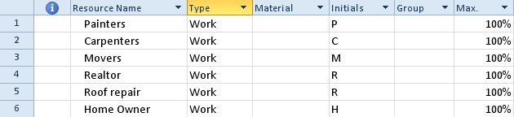

When a resource pool is opened the following Open Resource Dialog box will appear. Project 2010 has recognized that the file is a resource pool file and is asking how you want to open the file. The choices are:

* Open the resource pool read-only
* Open the resource pool read-write for maintenance
* Open the resource pool read-write as well as any sharer projects and combine into a new master file.

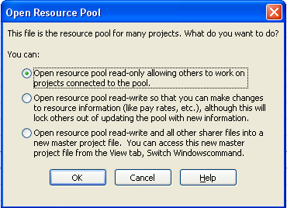

**To detach a project from the resource pool:**

* Open the project attached to the resource pool
* **Resources** 🡪 **Resource Pool** 🡪 **Share Resources**
* Click **Use own Resources**
* Click **OK** to close.

## Viewing Resource Usage in the Resource Pool



Once assignments have been made using the shared resource pool, combined project assignments can be viewed using the Resource Usage View and the Team Planner View. In the example below, Selling House A & Selling House B are sharing the resource pool. Assignments have been created in each project.

In the view below, the Project column has been inserted to clarify the project source for similarly named tasks. On the right side of the view the resource availability column has been added. The timeline has been set to a per week level.

**To view the Resource Usage View:**

* **Task** 🡪 **Resource Usage**

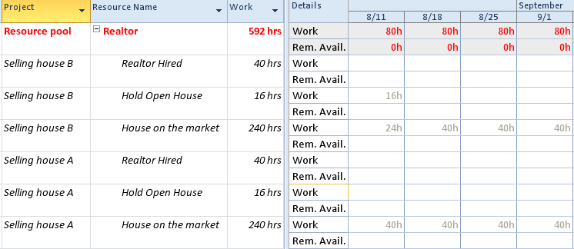

For Project Professional 2010 users the Team Planner View is a helpful source to see assignements from multiple projects on one screen. The Team Planner View is a resource based view and the project column cannot be added. To view the source of the task for an assignment block, hover your mouse pointer over the block and a pop up window will appear. This view could also be used to resource level resources across multiple projects.

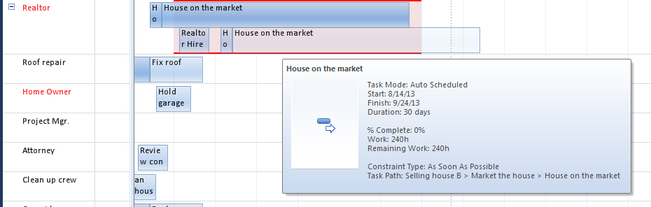

## Practice: Working with Resource Pools



*The Practice page is where you write detailed instructions for completing work listed as Exercises.*

*Type the Exercise Title and write a brief summary what the student will be doing in the exercise. Then list your ideas what they will be doing.*

*SAMPLE*

*In this practice you will create a Project Server Authentication profile and then configure the local cache settings in Project Professional 2007.*

*Exercise 1: Create Project Server Authentication Profile*

*In this exercise you will create Project Server authentication profile to connect to the Project Web Access site.*

Perform the following exercise on the PS07 virtual machine.

1. *From the* ***Start*** *menu, click* ***All Programs*** *🡪* ***Microsoft Office*** *🡪* ***Microsoft Office Tools*** *and click* ***Microsoft Office Project Server 2007 Accounts****.*
2. *In the* ***Project Server Accounts*** *dialog box, click* ***Add****.*
3. *In the* ***Account Properties*** *dialog box, and complete the following settings and click* ***OK****.*

|  |  |
| --- | --- |
| *Setting* | *Perform the following:* |
|  | |
| *Account Name* | *Type* ***Project Server*** |
| *Project Server URL* | *Type* ***http://epm/pwa*** |
| *When connecting* | *Select* ***Use Windows user account*** |
| *Set as default account* | *Select check box* |

# Lesson 3: Working with Master and Sub-Projects



Project managers are usually managing more than one project. When multiple projects are related they are called Programs. Project managers might have other project managers who are helping them manage subprojects related to larger projects. Master Projects are an easy way to work with multiple projects and see the big picture for the entire project when necessary.

In this lesson we will discuss:

1. Overview of Master Projects
2. Creating a Master Project
3. Inserting sub-projects

## Overview of Master Projects



A Master project is a project that contains inserted projects, called sub-projects. The insert projects may be related to a program or a group of unrelated projects.

Some advantages of working with Master Projects include:

* Sub-projects may be maintained by multiple project managers and the results will appear in the Master Project.
* Master Projects differ from New Window in that the projects are actually inserted into a Master file and will remain with the Master file.
* When a Master Project is opened, the sub-projects are optionally opened.
* Sub-projects may be inserted in read-only or read-write mode.
* Sub-project data may be linked to the data contained in the Master file.
* Changes made in the Master Project will reflect in the member projects.
* Master projects allow for pulling together of multiple projects for reporting.
* Custom objects created may be used across the projects.
* Works well with related and unrelated projects.

## Creating a Master Project and Inserting Sub-projects



**To create a Master Project:**

* **File** 🡪 **New** 🡪 **Blank Project** (double click)
* **File** 🡪 **Save As** (Best Practice: name file to reflect that it is a Master file)
* Click **OK**

**Best Practice:** *Turn on Project Summary Task*

* **Task** 🡪 **Gantt Chart** 🡪 **View** 🡪 **Project Summary Task**

Below is a view of a Master Project with project summary task:

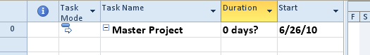

**To insert sub-projects into a Master Project:**

* Click in the **Task Name** for the next open task in the project.
* **Project** 🡪 **Sub-Project.**
* Navigate to the project schedule to be inserted.
* Select the file name.
* **Link to Project**: Click this option if you would like the Master file updated when changes are made to the sub-projects.
* Click the **Inserted** button to insert the sub-project in read-write mode.  
    
  OR
* Click the down arrow to the right of the **Inserted** button to select insert sub-project in read-only mode.

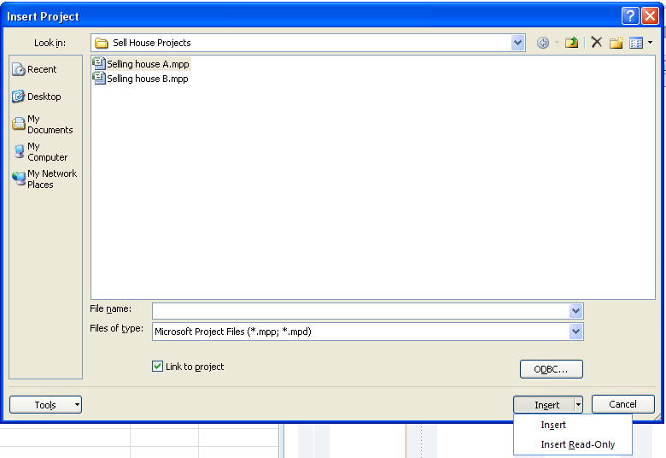

Below is a view with 2 projects inserted. Projects are rolled up to project summary tasks and are not actually opened until the + sign to the left of the project name is clicked. Note the summary bars. The Master project summary bar reflects the combined length of the all member projects and the sub-projects indicate the length of the individual sub-project only.

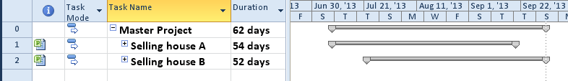

**NOTE:**

* *To remove an inserted project from a Master Project, select the project name, press the delete key and approve the deletion.*
* *If a project file will be using an external resource pool, share the pool with the project file before inserting the project into the Master Project.*
* *If inserting projects into a Master Project with existing inserted project open, the new inserted project will result as a sub-project of the open inserted project.*

## Leveling Resources across Projects



Resource leveling can occur across open projects sharing the same resource pool. When leveling occurs, priorities at the project level may be set to give one project priority for resources over another project.

Resource leveling can also be performed using the New Window option described above. If the same resource name exists in the multiple projects, they will be treated as unique resources and will not be combined.

**To level resources across Multiple Projects using a Master Project or a New Window:**

* Open the Master Project or open all projects to be leveled in a New Window.
  + If creating a New Window: View🡪 New Window🡪 select projects to be included 🡪 click OK
* Expand the outline level of the projects to open all projects and show all tasks.
* Adjust priorities for projects (optional)
  + Double click on the project summary task for a project
  + Alter the Priority on the General tab (1 = low, 1000 = highest)
  + Click **OK** to close the **Project Summary** dialog box
  + Repeat for each project
* **Task** 🡪 **Gantt Chart** 🡪 **More Views** 🡪 **Leveling Gantt** 🡪 **Apply**

Below is the Leveling Gantt view before leveling the work assignments. Note the red indicators in the Indicator column alerting overallocated tasks:

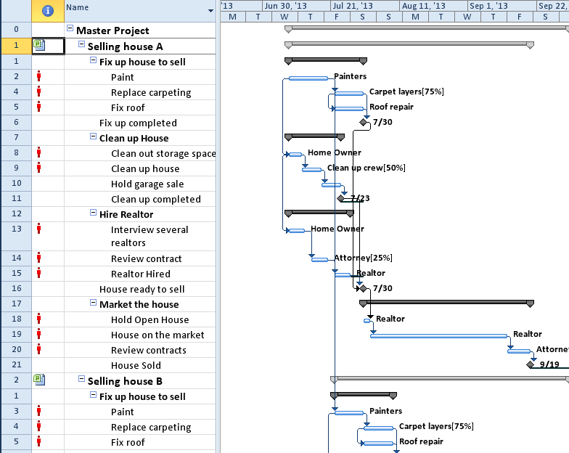

**To level resources in a Master Project or in a New window:**

* **Project** 🡪 **Resource** 🡪 **Level all**

The result of the resource leveling is shown below. The Leveling Gantt view will show before leveling status (in beige) and after leveling status (in blue). The resource overallocations have been solved and the schedule dates for all tasks have been affected:

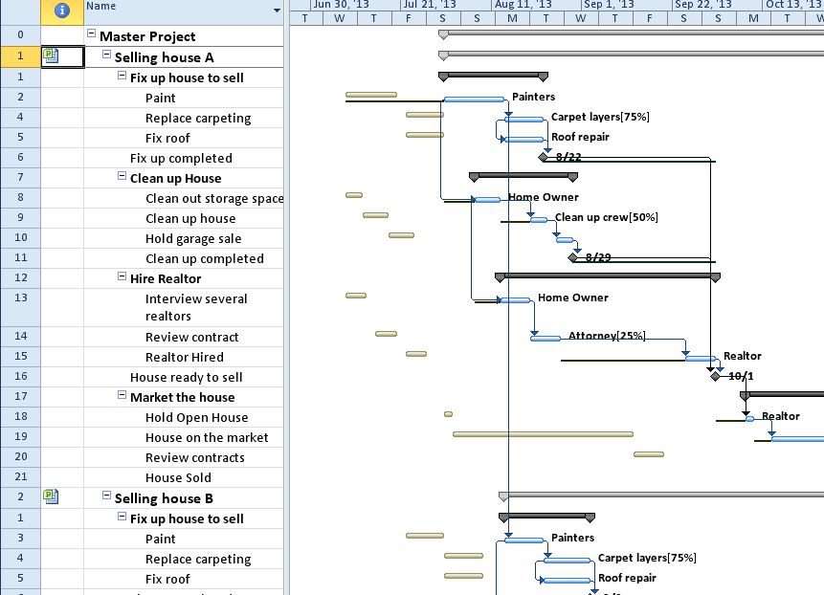

## Practice: Working with Master and Sub-Projects



*The Practice page is where you write detailed instructions for completing work listed as Exercises.*

*Type the Exercise Title and write a brief summary what the student will be doing in the exercise. Then list your ideas what they will be doing.*

*SAMPLE*

*In this practice you will create a Project Server Authentication profile and then configure the local cache settings in Project Professional 2007.*

*Exercise 1: Create Project Server Authentication Profile*

*In this exercise you will create Project Server authentication profile to connect to the Project Web Access site.*

Perform the following exercise on the PS07 virtual machine.

1. *From the* ***Start*** *menu, click* ***All Programs*** *🡪* ***Microsoft Office*** *🡪* ***Microsoft Office Tools*** *and click* ***Microsoft Office Project Server 2007 Accounts****.*
2. *In the* ***Project Server Accounts*** *dialog box, click* ***Add****.*
3. *In the* ***Account Properties*** *dialog box, and complete the following settings and click* ***OK****.*

|  |  |
| --- | --- |
| *Setting* | *Perform the following:* |
|  | |
| *Account Name* | *Type* ***Project Server*** |
| *Project Server URL* | *Type* ***http://epm/pwa*** |
| *When connecting* | *Select* ***Use Windows user account*** |
| *Set as default account* | *Select check box* |

# Summary



Managing more than one project at a time can be a challenge. Having more information concerning the multiple projects accessible to the project manager will aid with making decisions. Projects that are related can be combined into a Master Project. Unrelated projects can remain separate and when needed be pulled together to create combined reports. Whether projects are related or unrelated, resources can be shared over multiple projects and leveled.

In this module we discussed:

1. Linking Multiple Projects
2. Master Projects
3. Working with Resource Pools